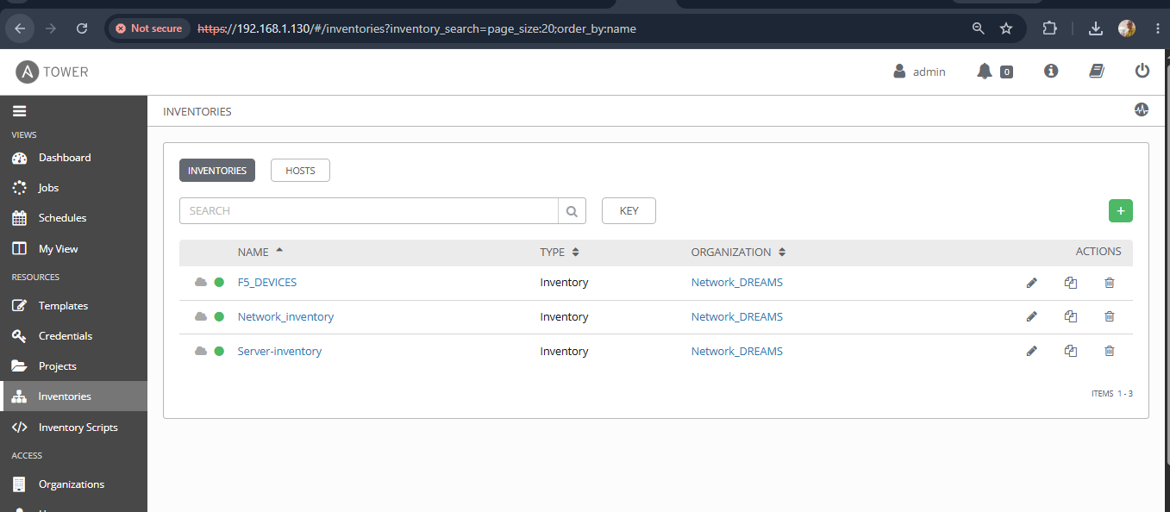

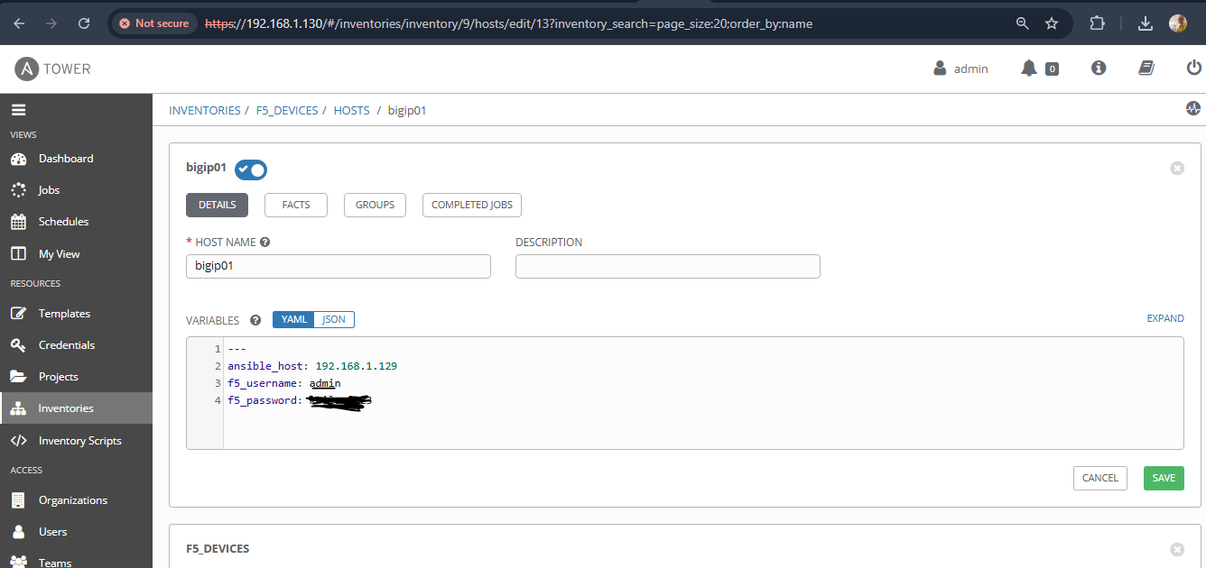

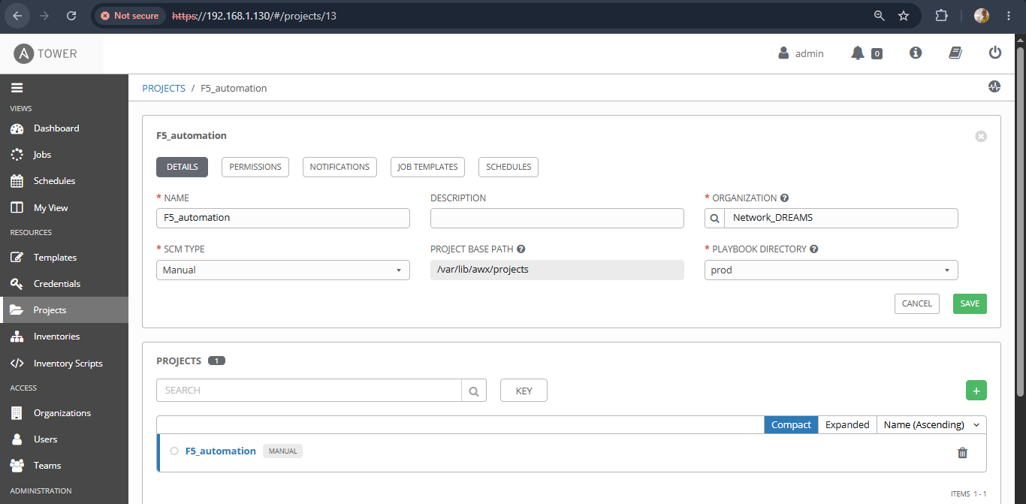

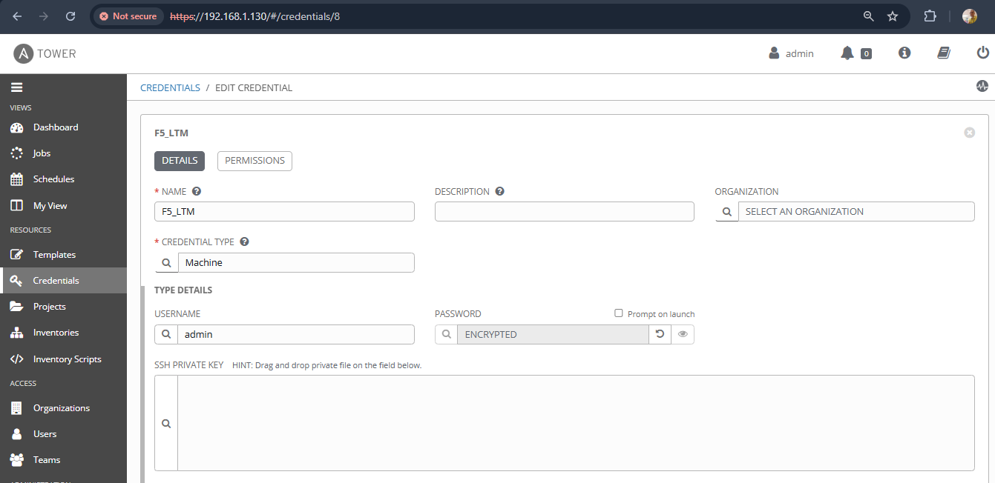

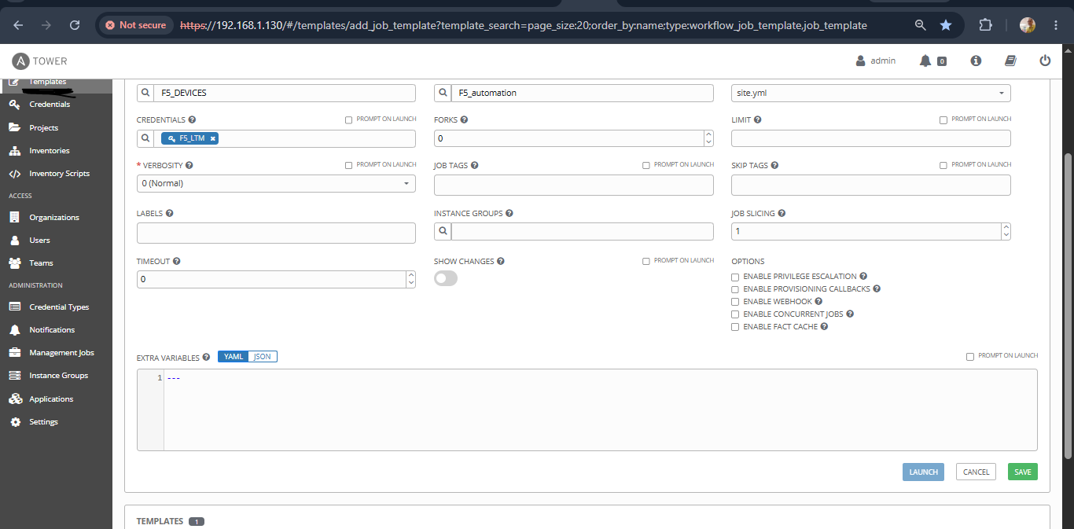

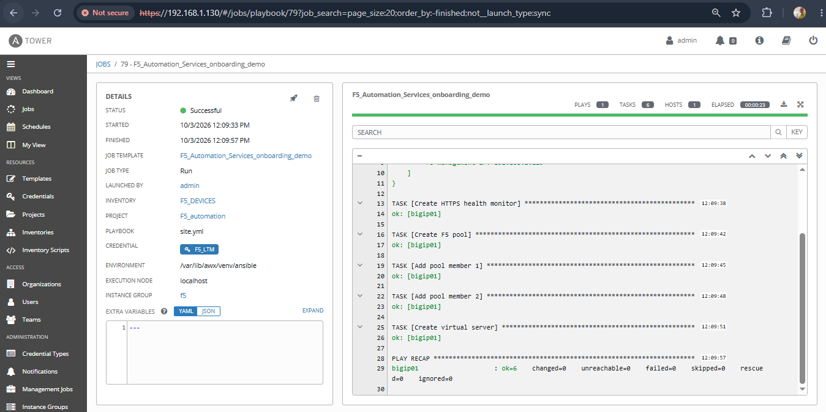

[root@localhost prod]# ls
1 collections connectivity.yml inventory requirements.yml site.yml web.yml
[root@localhost prod]# cat site.yml
---
- name: Create F5 LTM VIP and Pool
hosts: all
connection: local
gather_facts: false

collections:
- f5networks.f5_modules

vars:
f5_provider:
server: "{{ ansible_host }}"
user: "{{ f5_username }}"
password: "{{ f5_password }}"
validate_certs: false

tasks:

- name: Show F5 connection information
ansible.builtin.debug:
msg:
- "Inventory host: {{ inventory_hostname }}"
- "F5 management IP: {{ ansible_host }}"

- name: Create HTTPS health monitor
f5networks.f5_modules.bigip_monitor_https:
name: MON_APP01
provider: "{{ f5_provider }}"
send: "GET /"
receive: "HTTP"
interval: 5
timeout: 16
state: present

- name: Create F5 pool
f5networks.f5_modules.bigip_pool:
name: POOL_APP01
lb_method: round-robin
monitors:
- MON_APP01
provider: "{{ f5_provider }}"
state: present

- name: Add pool member 1
f5networks.f5_modules.bigip_pool_member:
pool: POOL_APP01
name: APP01_MEMBER_1
host: 10.10.10.11
port: "443"
provider: "{{ f5_provider }}"
state: present

- name: Add pool member 2
f5networks.f5_modules.bigip_pool_member:
pool: POOL_APP01
name: APP01_MEMBER_2
host: 10.10.10.12
port: "443"
provider: "{{ f5_provider }}"
state: present

- name: Create virtual server
f5networks.f5_modules.bigip_virtual_server:
name: VIP_APP01_HTTPS
destination: 192.168.1.200
port: "443"
pool: POOL_APP01
ip_protocol: tcp
profiles:
- http
provider: "{{ f5_provider }}"
state: present
[root@localhost prod]#

